Olympia Weavers Guild
Point of Sale Application
Artist’s Instructions for 2023
A Note for Everyone: Please read the full set of instructions before beginning.
A Note for Returning Users
- If you have an Artist Inventory with a 2023 date at the top, you are good to go. If you do not have a spreadsheet with that date, please request one.
A Note for New Users
- Request electronic copy of Artist Inventory Spreadsheet. (If you do not have access to a computer with Excel spreadsheet capability, ask a friend to assist you or contact Ardith Hamilton at ArdithJH@hotmail.com.)
- Save the spreadsheet to your computer and make your entries, consulting the instructions below.
- Enter your first name, last name, last four digits of your telephone number, and the email address you wish us to use. This information will be used to create a unique identifier for your inventory items and to email your tags and spreadsheet to you. All other items in this section will be automatically filled in. (Note to returning users; If you change your phone numbers, you will be issued a new ID and any existing tags will have to be changed. You may wish to use the existing numbers to save having to change all your old tags.)
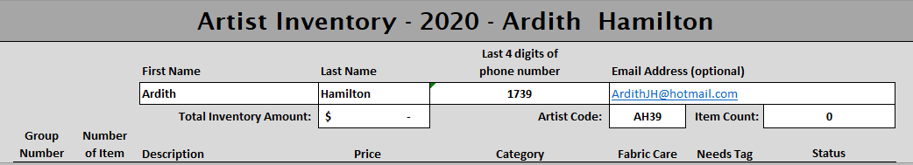
Prior to the Sale (all users)
- Complete a full line for each item you are submitting for the Show and Sale.
- Save the spreadsheet for your personal use and email a copy to the System Manager.
- Within a week, you should receive your Inventory tags by email. Tags will not necessarily be printed in order, as fabric care and non-fabric care tags are different in size. Print your tags on a sturdy paper. Please do not use “sparkly” paper, make sure your barcodes are printed clearly, and remember that the barcode needs to be flat to be easily read.
- Complete the Fabric Care tags; cut your tags apart and attach them to the proper item (which is clean, ironed, and ready for display). MAKE SURE THE TAG GOES TO THE PROPER ITEM. When tagging, work with a copy of your spreadsheet to minimize errors.
- Category/Group Numbers: This number is determined by the category of item chosen. It is generated and entered on import. (For example, all woven scarves will have the Category/Group number 33; Item Numbers within that category will be sequential.)

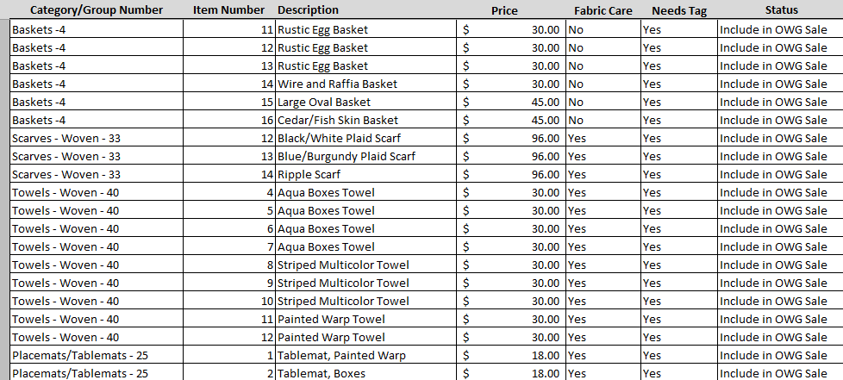
Example of Spreadsheet for 2022

- You will receive a copy of your spreadsheet when your tags are sent to you which will reflect what has been imported into the system. This is the “official” copy, some numbering may have been changed with the import. If, after receiving your tags, you wish to “update” your spreadsheet (add or subtract additional items) you are welcome to do so in the following manner:
- Using the most recent copy of the spreadsheet, assure that the “needs tag” column is “no” for all previous items;
- Enter the new item(s) or change an old item to “delete” or “exclude from OWG sale”;
- If you enter new items, make sure “needs tag” is yes;
- Save the spreadsheet;
- Email the revised spreadsheet as before. (You will receive tags for the new items if requested and a copy of the new spreadsheet.)

On the Day of the Sale
- Deliver items to the sale location at the designated time. Include a SASE if you wish your check to be mailed to you. No further paperwork is needed from you at this time.
At the End of the Sale
- A copy of your Artist Sales Report will be provided to you when you arrive to pick up remaining items and will indicate items not sold.
- Collect your remaining items, making sure there are no apparent discrepancies. Report any issues to a member of the Show and Sale Committee immediately.
General Guidelines for the Spreadsheet
- Space is available for 1000 line items.
- It is okay to skip lines.
- If you are entering an item, all columns must include information. If a line is incomplete, it will not appear in the inventory.
- Items do not have to be in numerical order, they will be sorted in numerical order when imported.
- If you enter a duplicate number while listing items, the duplicate items will appear in red print, as will a banner in red across the top of the spreadsheet indicating that a duplicate has been entered. Simply renumbering the item you are entering will resolve this problem and red will disappear from your spreadsheet.
- All existing item deletions should be made by choosing “delete” in the Status column. Do not attempt to add or subtract lines from the spreadsheet or highlight and delete text. If there are a lot of deletions to be made you may wish to submit your spreadsheet early for that purpose. We will import it and generate a “new” version for you that will appear without those items, freeing up lines you may wish to use.
Definitions/Explanations of Terms used
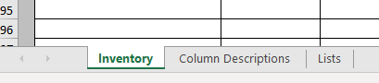
- At the bottom of your spreadsheet you will find buttons labeled “Inventory”, “Column Descriptions”, and “Lists”.

- Clicking on “Inventory” displays your spreadsheet.
- Clicking on “Column Descriptions” displays a list of the column names, a description of their function, and further explanation if applicable.
- Clicking on “Lists” displays column choices for “Category/Group Number”. This is a fixed list that allows the system to determine the Group Number and consistently gather information about inventory and sales.
Thoughts on the Point of Sale System
- Please take the opportunity to provide feedback to the System Manager about the system.
- Consider utilizing your spreadsheet as a personal inventory for your items. It will not be necessary to retag any unsold items for the next year’s sale.

